**Exhibitors**

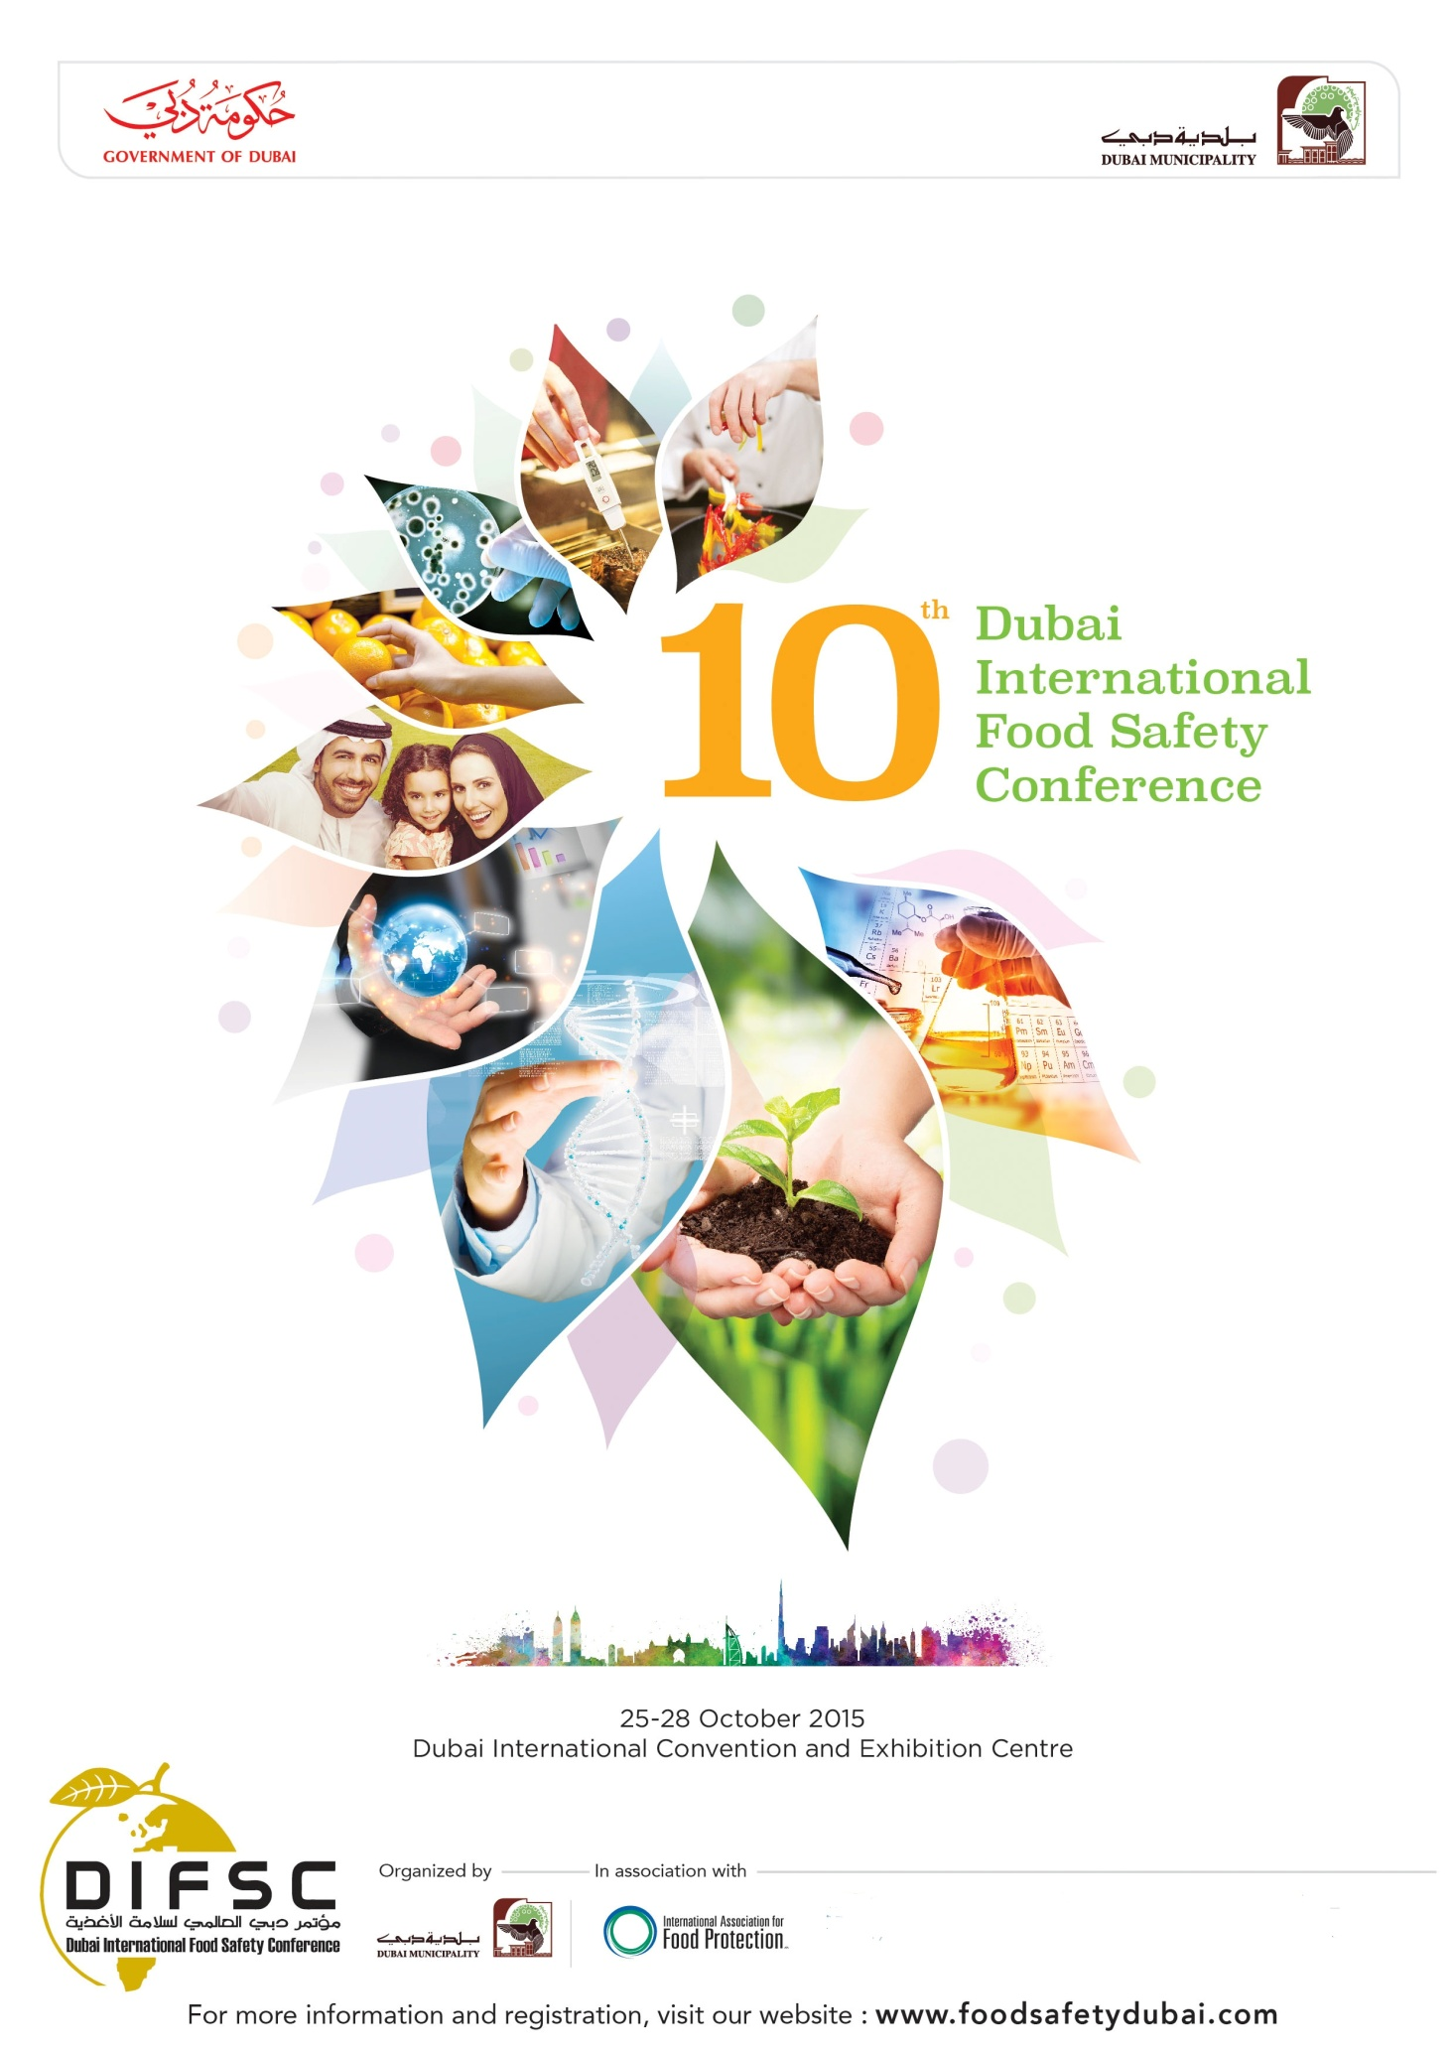

**Bureau Veritas – Food Services**

**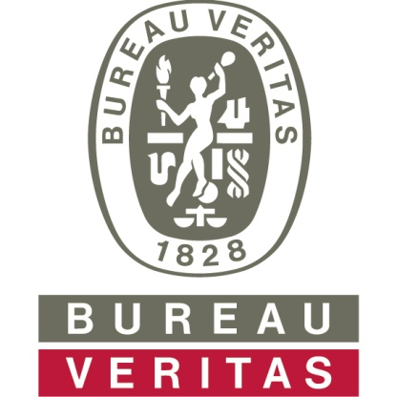**

Bureau Veritas is a world leader in Testing, Inspection and Certification services. We work closely with our clients to effectively manage quality assurance needs throughout their supply chains and mitigate risks in terms of quality, health, safety, social responsibility and environment, thus protecting brand reputation and minimize costs. We offer a wide range of services to help meet the needs and minimize risks of your business. Our proactive services maximizes control at every link in the supply chain – from farm to fork approach which help you in achieving your customer safety and food safety goals.

With Bureau Veritas as your partner, we will support and guide you through the whole process offering you a wide range of effective solutions for your business needs including auditing, certification, testing, inspection, scientific and regulatory consulting, technical solutions and training.

**MEFOSA & MENA**

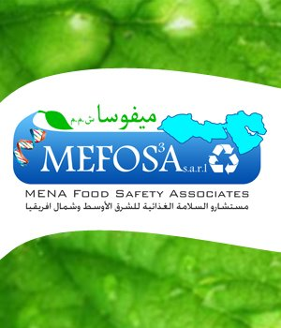

MEFOSA s.a.r.l. (MENA Food Safety Associates) was formed to assist companies hone their competitive edge by establishing and verifying procedures and practices that ensure quality, wholesome and safe products. We provide technologies ,IT & Tractability solutions, consulting, auditing and training services in TQM,ISO,HACCP, GMPs, Hygiene and more. MEFOSA can help you move your business into a leadership position through science based food safety.

Representing MEFOSA in MENA can take many forms certain market in our region have nascent food safety needs ; yet we believe Developing Nations are most in need of our technologies and services . Here pleased be advised that MEFOSA can offer its clients commercial representation in the format of a : Freelancer , Reseller , Distributor, or  Agent . Moreover , MEFOSA can be your partner in Franchising ,and even in Joint Venture opportunities for specific projects of interest.

**United Registrar of Systems (URS)**

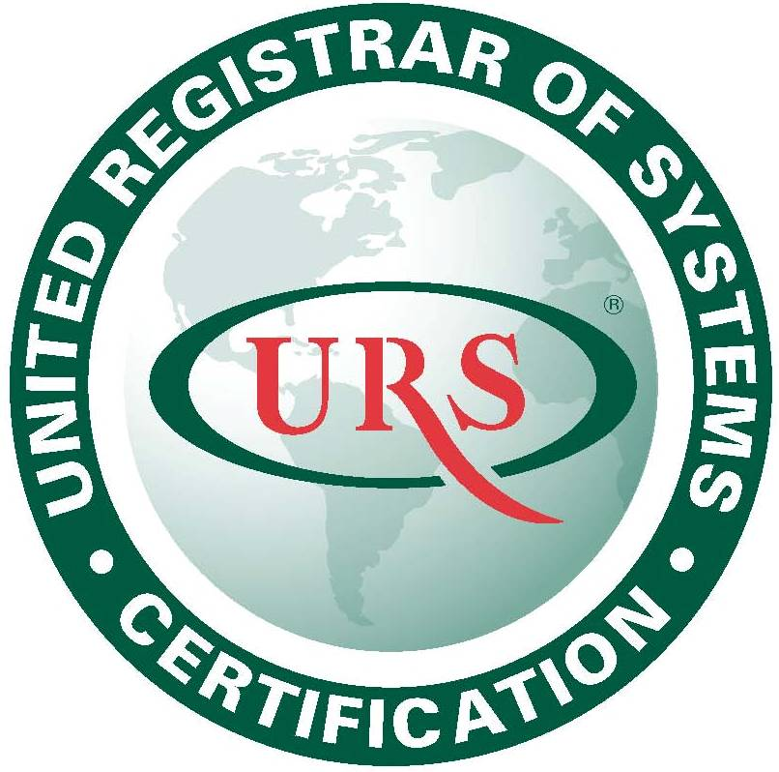

**United Registrar of Systems (URS)** is a UK based certification and selected **UKAS** as its Accreditation Agency. URS (ME) has got Accreditation from **Dubai Accreditation Centre (DAC)** for ISO 22000 & HACCP certification schemes. URS core business is the assessment and subsequent judgment of an organization’s management system, with respect to compliance to external standards. URS services are available over 64 countries including **USA, UK, Europe, Asia, Africa and Far East countries**.

**Chartered Institute of Environmental Health (CIEH) Middle East**

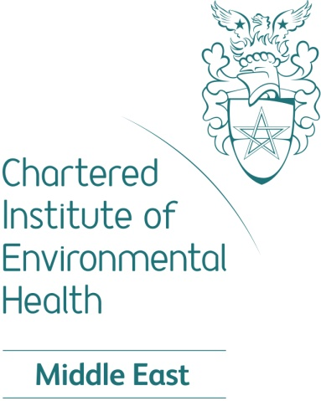

The roots of the CIEH go back to the 1840s. Over the centuries it has established a reputation as a trusted and respected institute, awarding and campaigning organisation and membership body.

The CIEH set standards, accredit courses and develop a range of safety and compliance qualifications and training solutions.

**Awarding organisation**

Its global network of 10,000 Registered Trainers and Centres are supported through events and training materials to ensure qualifications are delivered to the highest standard.

To assist employers to comply with legal requirements and best practice, a range of safety and compliance training solutions are available from the CIEH. These include, for example, qualifications, eLearning, qualification development, professional consultancy and project delivery, and assurance to complement existing in-house training. The CIEH portfolio includes; food safety, PIC, health and safety, first aid, fire safety, environmental management and education and training and many more.

**Reputation and accreditation**

The organisation’s Royal Charter requires the CIEH to: ‘secure and justify the confidence of the public’ in our members and in the environmental health sector.

CIEH qualifications are internationally recognised, and are regulated by OFQUAL, Welsh Government, Department for Education and Skills (DfES) and the Council for the Curriculum Examinations and Assessment (CCEA). The CIEH is certified under ISO 17024 in Dubai by the Dubai Accreditation Centre (DAC). ISO 14001 registered Environmental Management. BS 8900-2 registered Sustainable Development.

Visit [www.cieh.org/middleeast](http://www.cieh.org/middleeast) for more information.

**ASM Quality Certification**

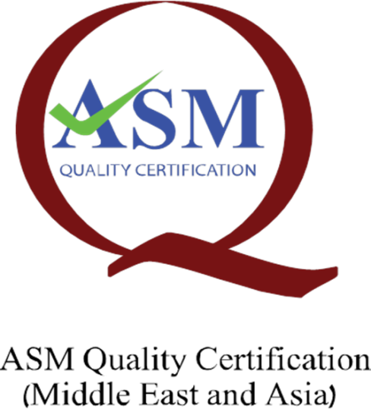

**ASM Quality Certification** is a specialized firm in the business of

**‘Certification’** of enterprises for Food safety standards like the HACCP/ ISO

22000:2005 and provides a wide-range of certification services in Food Safety

Management Systems (FSMS) under the name “**ASM QUALITY CERTIFICATION”(**

**ASMQC), Dubai.** In the food production sector any organization regardless

of size involved in any aspect of food chain should strive to provide

consistently safe products and should demonstrate its ability to control any

food safety hazards in order to ensure that food is safe for human consumption

and such ability can be evaluated by ASMQC through a set of well-defined

process and certified.



**Pulseberry Health Consulting**

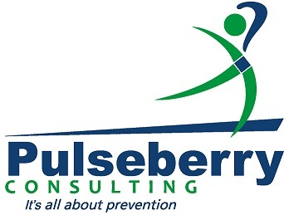

Pulseberry Health Consulting is an international food safety, quality, environmental and occupational health and safety management system consultancy organization. We provide trusted technical and management services to national and international companies, in all industry sectors where quality, food safety, environment and health and safety are a critical factor.

We help our clients evaluate and manage quality, food safety and environmental related business risks.

We understand that every company and every situation is unique. So we work closely with our clients to carefully define their needs, identify the best solutions, and add to internal resources and capabilities.

**UNIQUE MIX OF COMPETENCIES AND RESOURCES**

Our team of industry experts has in-depth industry experience and knowledge of Quality, Food Safety, Health & Safety and Environment management systems. Their competencies and skills are complemented through alliances with noted world leading organizations in Quality, Health, Safety and Environment consultancy, independent auditing and risk engineering organizations. This truly unique combination of professional capabilities and expertise helps Pulseberry Health Consulting deliver a complete mix of solutions.

**Campden BRI:- Practical application of technical excellence for the food a and drink supply chain.**

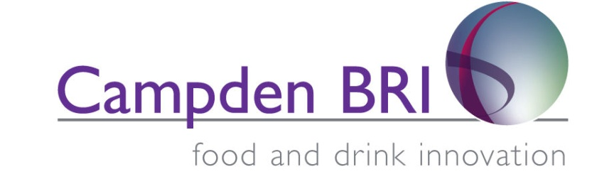

We provide the food and drink industry with the practical scientific, technical and advisory services needed to ensure product safety and quality, process efficiency and product and process innovation.

Our services can loosely be categorised under four pillars:

**Analysis and testing** - microbiological, chemical, physical and sensory analytical services - helping to ensure safety and optimise product quality

**Operational support** - helping companies 'do the day job'. Troubleshooting manufacturing problems - ingredients, processing, packaging, advising on hygienic design and maintenance, supporting implementation of systems such as HACCP and risk management, and helping with product development

**Research and Innovation** - industrially relevant research chosen and funded by members, as well as work for government departments and agencies

**Knowledge Management** - industrial best practice guideline publications, a wide range of training courses, seminars and conferences, and expert technical and legislation information and advice

More information at [www.campdenbri.co.uk](http://www.campdenbri.co.uk) or Email info@campdenbri.co.uk

**Geo-Chem Middle East**



Geo-Chem Middle East is an internationally recognized independent inspection and testing company with extensive experience in inspection, survey and testing of diverse export/import cargo.Headquartered in Dubai in Techno Park, near Jebel Ali Free Zone, the company has a global presence with independent offices and affiliates in 25 key markets in the Middle East, North Africa, South Asia, Europe and the US. The Dubai operations are complemented by a fully-fledged office and laboratory in Fujairah, the world’s second largest bunkering location, with Geo-Chem offering specialised environmental, bunker fuel and finished product testing.

The key differentials of Geo-Chem Middle East are state-of-the-art laboratories across the GCC major cities for testing, inspection and calibration services managed by a large pool of talented professionals. We have a strong geographic presence in all major markets.

Geochem laboratory is ISO 17025 accredited by GAC (Gulf Accreditation Center) and DAC (Dubai Accreditation Center). The commercial laboratory division scope is for Chemical and Microbiological anlysis in Food,Water,Waste Water,Environment Swabs,food contact materials. Our hydrocarbon division scope covers Standard Used Oil lubricant analyses (OCM), Transformer Oil and Gas analyses, Marine Gas Oil and Residual Fuel Oil.

At Geo Chem Middle East we have continuously develop a culture in which EHS(Environment, Health & Safety)is a part of everyone's job as we believe it is the right thing to do for each other, our communities, our business and our customers. Geochem ME EHS management system is certified to OHSAS 18001 and ISO 14001 which provides consistent guidance to our diverse operations.

High field Awarding Body for Compliance (Middle East) Asia

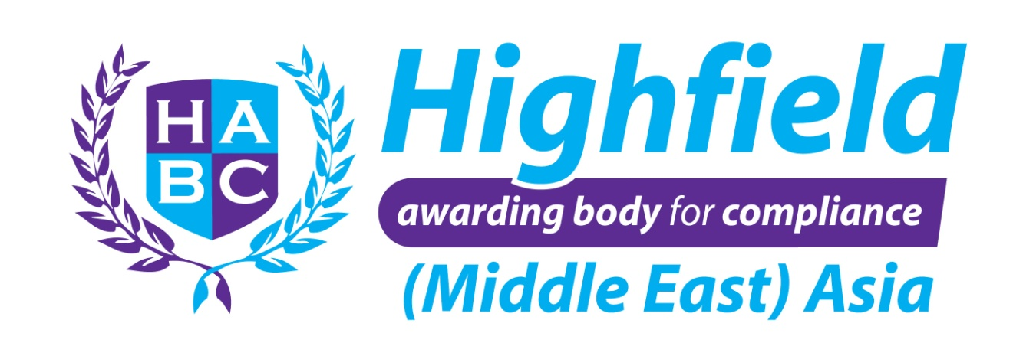

HABC is the World’s leading Awarding Organisation for safety and compliance qualifications and training materials. HABC has over 10,000 trainers and training centres offering international qualifications worldwide to many prestigious organisations.  We have a strong presence in the Middle East and Asia, with our MEA Office located in Dubai.  HABC provides over 250 qualifications in a wide variety of sectors, including: Food Safety (Person in Charge), First Aid, Fire Safety, Health & Safety and Security.  HABC is committed to Quality, Value, Service & Integrity.

**Pal International Ltd**

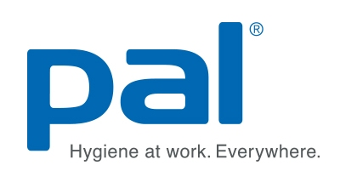

Established in 1970 with over forty years of experience, Pal International provides complete hygiene solutions for the workplace. Our head office, manufacturing plant and European warehouse are based in Lutterworth, Leicestershire in the heart of the UK.

Pal International specialises in the design, development and manufacture of disinfectant wet wipes products for the food & beverage, healthcare and industrial sectors. Our food & beverage wipes products are developed by our own chemists and microbiologists and contain bespoke chemical solutions and materials developed specifically to reduce the risk of infection from food borne micro organisms. Our wipes are manufactured in the UK and are used in food & beverage manufacturing and processing environments and food service areas in over 50 countries as best practice in the area of food safety.

Through our focus on innovation and partnership we continue to grow globally and has established Pal brand as a trusted brand across many sectors, ranging from food manufacturing and HORECA, to healthcare, janitorial, industrial and agriculture.



**Neogen Europe**



Neogen Europe has been developing and supplying diagnostic kits and expert services to determine the quality and safety of food and agricultural products since 1998. Neogen offers on-site diagnostic kits and laboratory testing services to detect mycotoxins, marine and other natural toxins, speciation and allergens as well as a wide range of products for traditional and rapid microbiology, pathogens and spoilage organisms. Neogen also offers a complete hygiene monitoring system.

**Advanced Biotechnology Centre (ABC)**



Advanced Biotechnology Centre (ABC), experts in the area of **Food**,**Water** and **Air** analysis was established in 2003 in Dubai. We are an approved & accredited lab under the Dubai Municipality and is also the first and the only private DNA based testing lab in the GCC which is accredited to **ISO-17025** standards by Dubai Accreditation Centre (DAC). The Lab has been providing various testing services in sectors like Food and Environment(Water/Air), Molecular Services etc for clients who engage our expertise for various analysis done using common conventional methodologies to the high end DNA based technologies.

 We specialize in **DNA based testing** and **monitoring** in ***Food, Water quality assessment/analysis*** and ***Indoor Air Quality*** Monitoring. Specific pathogens in food and water like salmonella, pseudomonas,legionella etc can be tested by utilizing our DNA based method which is much more faster and relaible. Pathogens which are un identifiable using conventional methodologies can be identified with the help of our **Microbial identification** services done by Ribosomal DNA sequencing method. Please find the attachments which could give you further information on Food borne pathogen detection and testing capabilites of ABC.Our expertise can also provide trainings related to Air and Water risk assessments etc.

 To know more in detail on all services provided by ABC,You may log on to our website [www.abc.ae](http://www.abc.ae). Further If you have any enquiries or require more clarifications on our services, please get in touch with us via the contact details provided below. We at ABC, would be glad to serve you with the best of our service where you will be able to utilize our expertise and capabalities in a cost-effective way.

**TÜV MIDDLE EAST**

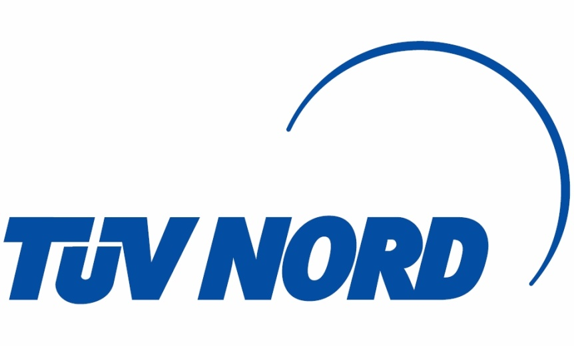

Founded in 1984, TUV Middle East, is a subsidiary of TÜV NORD GROUP and is the leading center for Inspections, Testing, Assessments, Auditing, Certification and Training in the Middle East. With more than 250 experts in all fields, TÜV Middle East provides its partners with an extensive range of services and knowledge going beyond inspection and certification requirements.

With a world class reputation for integrity and partner satisfaction, TÜV Middle East is committed to ours partners and the community by delivering high innovative solutions to help our partners fulfill the growing demands of quality and safety while assisting in improving performance and encouraging social responsibility and sustainable practices.

TÜV MIDDLE EAST’s broad service profile and wide-ranging knowledge of regulations, standards, and markets helps you to ensure optimal performance, safeguard your brand, and reinforce your competitive advantage through inspection and certification.

**SERVICES**

* **Certification**
* **Training**
* **Microbiological, Water and Chemical Testing**
* **Inspection**
* **Etc.**

**Nestlé Middle East**

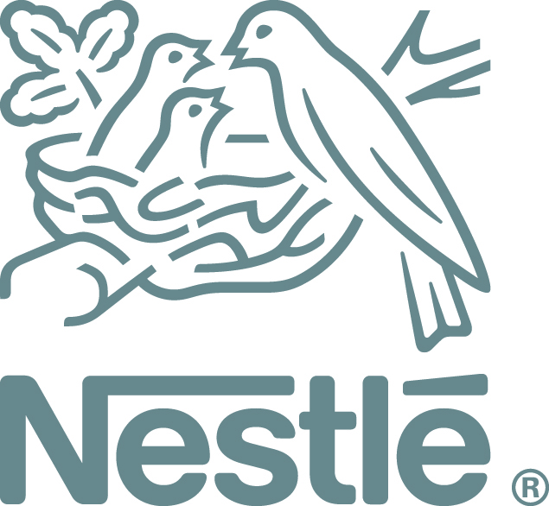

Nestlé Middle East’s heritage goes back 80 years to 1934 when the first import operation was set up in Lebanon. Today, Nestlé Middle East owns and operates 18 factories and provides direct employment to more than 11,000 people and indirect employment to several thousand more.

The Nestlé portfolio in the region currently exceeds 60 innovative product brands in a wide range of categories: dairy products and infant nutrition, bottled water, chocolate and confectionery, coffee creamers, breakfast cereals, and culinary products, among others. *Nestlé Nido*, *Nestlé NAN*, *S-26*, *Progress*, *Maggi*, *Nescafé*, *Kit Kat*, *Coffeemate*, *Nestlé Cerelac*, *Nestlé Pure Life*, *Nespresso* and *Nestlé Fitness* are just some of the brands available in the Middle East.

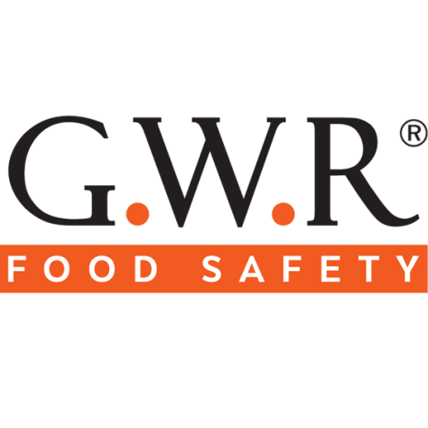

**Brandenburg UK Ltd**

****

Brandenburg is the World's leading designer and manufacturer of pest management products including flying insect traps and bed bug monitoring devices. Our Genus® range of insect light traps provide the fastest fly catch with the lowest running costs to provide superior protection against pathogens transmitted by flies.

Our position as the World’s leading manufacturer of sustainable pest management and hygiene products means that specifiers, wholesalers, distributors and managers can be confident that they are selecting from the most technically advanced, proven range available.

All of our products are manufactured using the highest quality materials and components at our own factory in the United Kingdom.

**RMK The-Experts**



**RMK The-Experts** offers it’s training and consulting services to all sectors of food production, processing, storing, catering, retailing and servicing of any size and everywhere. We are proud of our very wide base of knowledge and expertise in the Food Safety matters, thanks to the vast experience of our company founder, Dr. Rafiq Al Khatib, spanning over half a century, who made it available to our company to be utilized in food safety training, learning and consulting.

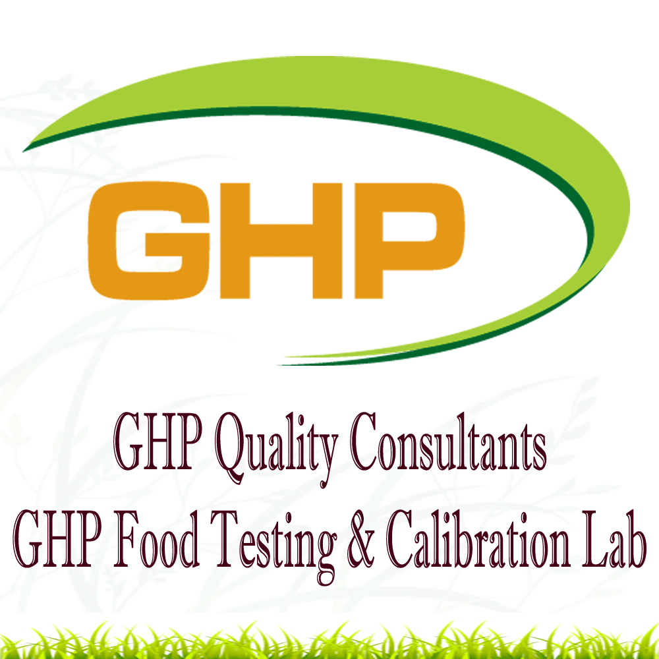

GHP Testing & Calibration Lab is an ISO 17025 DAC accredited laboratory, registered under Dubai Municipality. GHP offers a wide range of services like Food Testing, Calibration and Environmental Monitoring. In Food Testing, GHPs main focus are Pathogen Detection and Analysis of Food Composition, Food contaminants, Food toxicants, Food additives, Vitamins & Minerals and Water. In Calibration GHPs main focus are test the equipment accuracy for temperature, pressure and weights and certify as per the standards. In the Environment, Health & Safety sector GHPs main focus are Environmental Monitoring for air, water, soil & noise.

Apart from the laboratory services, our parent company - GHP Quality Consultants provides a wide-range of consulting services to various food and non food sectors to achieve various management system like Food Safety Management System (ISO 22000 & HACCP) and ISO Quality Management Systems (ISO 9001, ISO: 14001 & OHSAS 18001).

GHP is an approved and registered organization by various Govt. of Dubai, Sharjah and Ajman; Abu Dhabi Food Control Authority and JAFZA. GHP is also a registered member of The Royal Society for Public Health and High field Awarding Body for Compliance, whom are UK-based awarding bodies

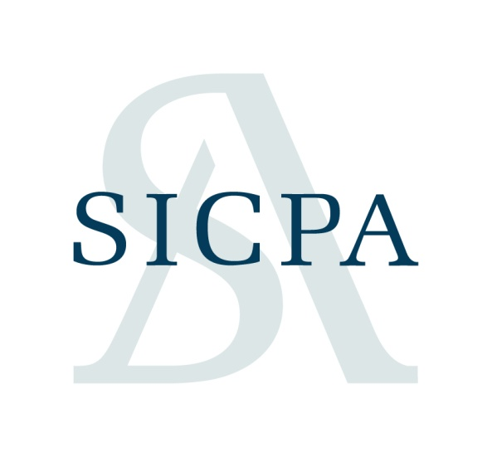

**SICPA**

SICPA is a leading global provider of secured authentication, identification and traceability solutions and services. Founded in 1927, headquartered in Switzerland and operating on five continents, SICPA is a long-trusted advisor to governments, central banks, high-security printers, and industry.

With high-technology security inks at the core of its expertise, the company protects the majority of the world’s banknotes, security and value documents from the threats of counterfeiting and fraud.

SICPA  integrates ink-based covert features and sophisticated traceability technologies to offer solutions and services to governments and industry, ensuring product authentication, traceability and protection as well as tax reconciliation. SICPA solutions are applicable at both national level and internationally across borders as a support for enabling trade.

 

**Mena Medical Supplies L.L.C** is in the field of supply and distribution of Medical, Laboratories & Healthcare equipment, disposable & reusable products. These products are aimed to improve the wellbeing of patients and enhance satisfaction of its customers. The company provides effective and safe Medical Products of high quality at reasonable prices.

With an aim to build up its success records, **Mena Medical Supplies L.L.C’s** mission on hand is to be the best in serving the medical & healthcare industry not only in U.A.E but also in the whole of the Middle East.

Even since the Medical Division of Mena Medical Supplies was initiated in the year 2007, the company has achieved an outstanding goal in getting an agreement with most reputed multinational companies in the healthcare field and also in the field of Food Manufacturing.

Our qualified and experienced personnel and efficient management system have earned the company a reliable reputation in Healthcare Industry & Food Manufacturing Industry in the U.A.E. Mena Medical Supplies deals in the supply and distribution of retail & wholesale of Healthcare products & Food Lab Products.

The company believes in furnishing services and providing the best and efficient customer services to their clients. To remain hand in hand with improving technology, the company constantly upgrades its services and products all the time.

With an aim to pursue recognized safety and quality standards, Mena Medical Supplies maintains a well-established quality control system that ensures all operations are monitored and controlled & conforms to specific environment conditions.

The receipt of its success has been a desire to reach un-scaled heights of success and meet customer satisfaction. Mena Medical Supplies falls nothing short of expectations in the U.A.E market and customers can expect nothing less than excellence from the company.

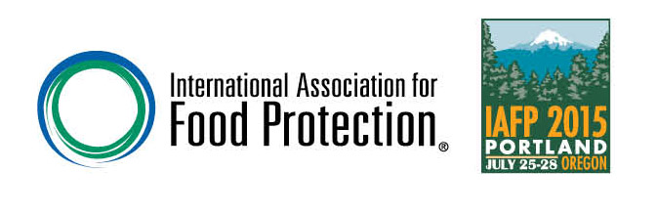

C:\Users\difsc_smzubair\AppData\Local\Microsoft\Windows\Temporary Internet Files\Content.Outlook\8RXN03JT\raqam consultancy.tif

RAQAM Consultancy Company is a leading Regulatory Consulting firm established in 2011 that has been dedicated to serve multinational and local Food and Beverage companies. RAQAM Consultancy deals with companies that produce, import, export and distribute FMCG products to the Middle East and North Africa. RAQAM covers Saudi, UAE, Qatar, Bahrain, Oman, Kuwait, Yemen, Iraq, Syria, Jordan, Lebanon, Egypt, Sudan, Libya, Tunisia, Algeria and Morocco and has stellar experience and local knowhow to achieve the best possible outcome.  
RAQAM provides support in the fields of [Food Regulatory Affairs](http://raqamconsultancy.com/regulatory-affairs.html), [Food Regulatory Compliance](http://raqamconsultancy.com/regulatory-compliance.html), [HALAL Compliance](http://raqamconsultancy.com/halal-compliance.html), [Supply Chain support](http://raqamconsultancy.com/supply-chain-support.html), and [Public Affairs and Government Relations](http://raqamconsultancy.com/public-affairs--government-relations.html).  
RAQAM Consultancy strives to achieve results that exceed expectations through our commitment to our clients, adding maximum value to their business, handling complex and sophisticated matters locally, nationally and internationally.



***About EUFIC Arabic***

*The European Food Information Council (EUFIC) is a non-profit organisation which communicates science-based information on nutrition and health, food safety and quality, to help consumers to be better informed when choosing a well-balanced, safe and healthful diet.*

*EUFIC communicates via its website* [*www.eufic.org*](http://www.eufic.org) *in 12 languages, with more Arabic content on the way. The development of Arabic-language content addresses professionals and consumers in a wide area focused on Europe, the Middle East and Africa (EMEA).*

*Information that EUFIC publishes has been subject to a review process by members of its* [*Scientific Advisory Board*](http://www.eufic.org/article/en/page/ONEUFIC/rid/eufic-scientific-advisory-board/) *(SAB). EUFIC consults with other scientific experts for specific projects in areas such as consumer research and science communication. Given the broad range of subjects addressed in EUFIC’s popular newsletter, Food Today, a dedicated* [*Editorial Board*](http://www.eufic.org/article/en/page/ONEUFIC/rid/eufic-editorial-board/) *for this publication provides additional insights and feedback.*

*When EUFIC content is translated to Arabic, it is reviewed by qualified professionals in the region to ensure that it is credible for health professionals generally and easy to understand by the general public, particularly when the unique cultural needs of the region are taken into account. Original EUFIC content specifically produced for the Gulf region with local academic partners is similarly subject to EUFIC’s balanced science-based approach.*

*Enquires about collaboration with EUFIC Arabic partners, and media enquiries may be sent to:* [***Arabic@eufic.org***](mailto:Arabic@eufic.org)

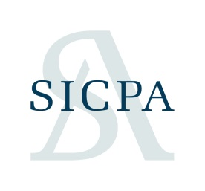

***About SCIPA***

*SICPA is a leading global provider of secured authentication, identification and traceability solutions and services. Founded in 1927, headquartered in Switzerland and operating on five continents, SICPA is a long-trusted advisor to governments, central banks, high-security printers, and industry.*

*With high-technology security inks at the core of its expertise, the company protects the majority of the world’s banknotes, security and value documents from the threats of counterfeiting and fraud.*

*With high-technology security inks at the core of its expertise, the company protects the majority of the world’s banknotes, security and value documents from the threats of counterfeiting and fraud.*

